### PROFESSIONAL TRAINING REPORT

#### at

**Sathyabama Institute of Science and Technology (Deemed to be University)**

Submitted in partial fulfillment of the requirements for the award of B.Tech (Bachelor in Technology) Bachelor of

Engineering Degree in Information Technology By

**R.A.D. SRIRAM REG. NO.40120139**



### DEPARTMENT OF INFORMATION TECHNOLOGY SCHOOL OF COMPUTING

**SATHYABAMA INSTITUTE OF SCIENCE AND TECHNOLOGY**

**JEPPIAAR NAGAR, RAJIV GANDHI SALAI, CHENNAI – 600119, TAMIL NADU**

**NOVEMBER 2022**

|  | **SATHYABAMA**  **INSTITUTE OF SCIENCE AND TECHNOLOGY**  **(DEEMED TO BE UNIVERSITY)**  **Accredited with Grade “A” by NAAC** (Established under Section 3 of UGC Act, 1956) JEPPIAAR NAGAR, RAJIV GANDHI SALAI  CHENNAI– 600119  [**www.sathyabama.ac.in**](http://www.sathyabama.ac.in/) |  |
| --- | --- | --- |

**DEPARTMENT OF INFORMATION TECHNOLOGY**

**BONAFIDE CERTIFICATE**

This is to certify that this Project Report is the bonafide work of

**R.A.D.SRIRAM (Reg. No: 40120139)** who carried out the project entitled “**INTERNET TRAFFIC PREDICTION ON DATA SCIENCE**”

under my supervision from June 2022 to November2022.

**Internal Guide**

**Dr.S.Gowari M.E., Ph.D.,**

**HEAD OF THE DEPARTMENT Dr. R. SUBHASHINI M.E., Ph.D.,**



**Submitted for Viva voce Examination held on**

**Internal Examiner External Examiner**

**DECLARATION**

I, **R.A.D.SRIRAM** hereby declare that the project report entitled “**INTERNET TRAFFIC PREDICTION ON DATA SCIENCE”** done by me under the guidance of **Dr . S.Gowari, Associate Professor IT Dept,** is submitted in partial fulfillment of the requirements for the award of Bachelor of Engineering Degree in Information technology.

**DATE:**

**PLACE SIGNATURE OF THE CANDIDATE**

**ACKNOWLEDGEMENT**

I am pleased to acknowledge my sincere thanks to **Board of Management** of **SATHYABAMA** for their kind encouragement in doing this project and for completing it successfully. I am grateful to them.

I convey my thanks to **Dr. T. Sasikala M.E., Ph.D**, **Dean**, School of Computing, **Dr.R.Subhashini,M.E..,Ph.D Head of the Department** of **Information technology** for providing me necessary support and details at the right time during the progressive reviews.

I would like to express my sincere and deep sense of gratitude to my Project Guide **Dr.S.Gowari, Associate Professor IT Dept.,** for her valuable guidance, suggestions and constant encouragement paved way for the successful completion of my project work.

I wish to express my thanks to all Teaching and Non-teaching staff members of the **Department** of **Information technology** who were helpful in many ways for the completion of the project.

**TRAINING CERTIFICATE**



Abstract

The advance knowledge of future trafﬁc load is helpful for network service providers to optimize the network resource and to recover the demand criteria. This paper presents the task of internet trafﬁc prediction with three different architectures of Deep Belief Network (DBN). The artiﬁcial neural network is cre-ated with the depth of 4 hidden layers in each model to learn the nonlinear hier-archal essence present in the time series of internet trafﬁc data. The deep learning in the network is executed with unsupervised pretraining of the layers. The emphasis is given to the topology of DBN that achieves excellent prediction accuracy. The adopted approach provides accurate trafﬁc predictions while simulating the trafﬁc data patterns and stochastic elements, achieving 0.028 Root Mean Square Error (RMSE) value on the test data set. To validate our choice for hidden layer size selection, further more experiments were done for chaotic time series prediction.

**TABLE OF CONTENTS**

| **CHAPTER NO.** | **TITLE** | **PAGE NO.** |
| --- | --- | --- |
|  | **ABSTRACT** | 6 |
|  | **LIST OF FIGURES** | 6 |
| **1** | **INTRODUCTION** | **10** |
| 1.1 Web Traffic Forecasting | 10 |
| 1.2 Data set web traffic forecasting | 11 |
| 1.3 COMMON MACHINE LEARNING ALGORITHMS AND GOALS | 11 |
| 1.4 Check the shape of the data | 12 |
| 1.5 Data Exploration for Web Traffic Forecasting | 13 |
| 1.6 Data preparation for web traffic forecasting | 15 |
| **2** | **AIM AND SCOPE OF THE PRESENT INVESTIGATION** | 17 |
| 2.1 Aim | 17 |
| 2.2 scope | 17 |

| **3** | **EXPERIMENTAL OR MATERIALS AND METHODS, ALGORITHMS USED** | **18** |
| --- | --- | --- |
| 3.1 Split the Dataset | 18 |
| 3.2. Scaling | 18 |
| 3.3 Model Building for Web Traffic Forecasting | 19 |
| 3.4 Define the optimizer and loss | 21 |
| 3.5 define the call back to save the best model during the training | 42 |
| 3.6 Baseline Model with forecasting | 43 |
| 3.7 CNN model with forecasting | 48 |
| **4** | **CONCLUSIONS** | 60 |
| **5** | **REFERENCES** | 61 |

| **FIGURE NO.** | **LIST OF FIGURES**  **FIGURE NAME** | **PAGE NO.** |
| --- | --- | --- |
| **1.1**  **1.2**  **1.3**  **3.1**  **3.2**  **3.3** | ***Visualize the whole dataset***  **First week web traffic**  **Data preparation for web traffic forecasting**  **Scaling**  **Base line model with forecasting**  **CNN model with forecasting** | **13**  **14**  **15**  **19**  **47**  **59** |

**CHAPTER-1**

**INTRODUCTION**

In this article we will pick the use case of sequence modelling, which is time series forecasting. Time series is all around us from predicting sales to predicting traffic and more.

A simple example of time series is the amount of year-on-year passenger traffic in the U.S. Formally, time series is just a series of data points arranged in time order or in sequence commonly taken us successive, equally spaced points time.

Time-series Database is the fastest-growing category of databases in the past two years, and both traditional and emerging technology industries have been generating more and more time-series data.

Now let’s try to understand the business use case that we tackling here.

## Web Traffic Forecasting

The web traffic is basically the number of sessions in a given time frame, and it varies a lot with respect to what time of the day it is, what day of the week it is, and so on, and how much web traffic of platform can withstand depends on the size of the servers that are supporting the platform.

If the traffic is more than what the servers can handle, the website might show this 404 error, which is something we don’t want to happen. It will make the visitors go away.

One solution to this problem is to increase the number of servers. However, the downside of the solution is the cause can go up, which is again undesirable. So, what is the solution?

## . Data set web traffic forecasting

We will deep dive into the web traffic data set and look at how we can use LSTM to solve this time series forecasting problem.

Now we will cover the problem statement of web traffic forecasting, and how it will help in scaling the resources, backing the outline publishing platform.

## Load Dataset for Web Traffic Forecasting

**Here we are reading the dataset by using pandas. It has over 4800 observatio**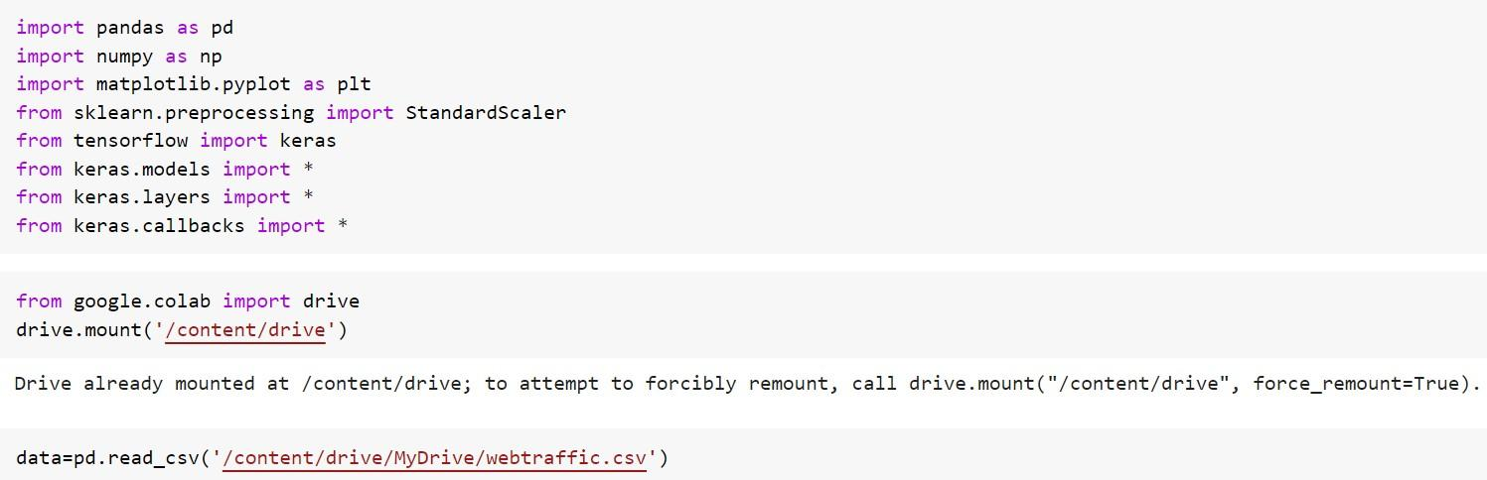

## Check the shape of the data

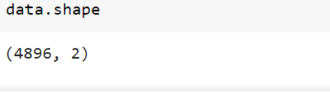

To print the first records of the dataset.



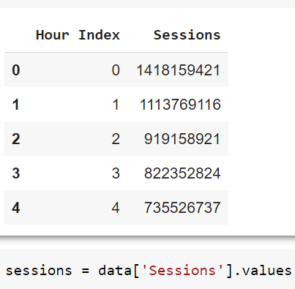

The first column is the hours as in this is the first hours, this is the second hour and so on.

And the second column session is the volume of traffic at an hourly level.

For example: - this is the number of sessions in the second hours and so on.

## Data Exploration for Web Traffic Forecasting

Now let’s explore the data, we will use the below code to plot the

entire time series there you go

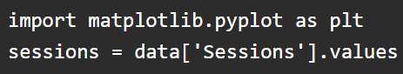

# Visualize the whole dataset

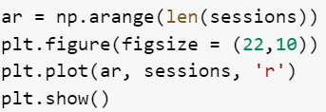

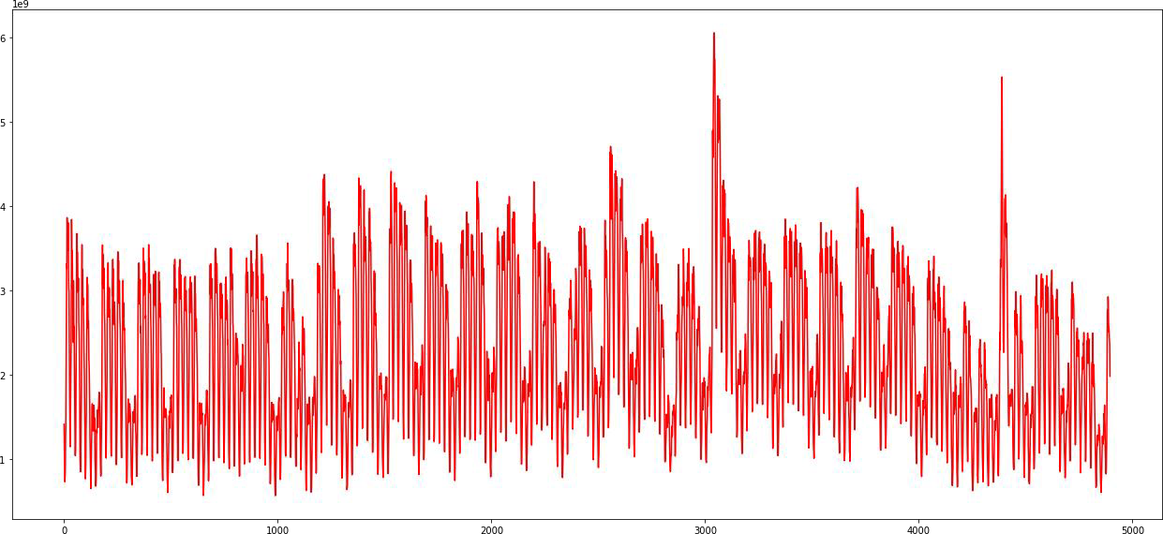

#### Fig 1.1: Each point of this curve is an early session count and you can see there are some repeating patterns throughout the time series.

The traffic volume comes down, after almost equal intervals of time. Apart from that, there are a couple of spikes as well in the traffic, In this plot.

Let’s explore this data, at a more granular level, we can use the below code and replace the entire time series, with a subset of it

## First week web traffic

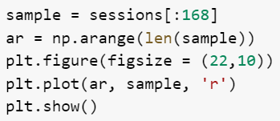

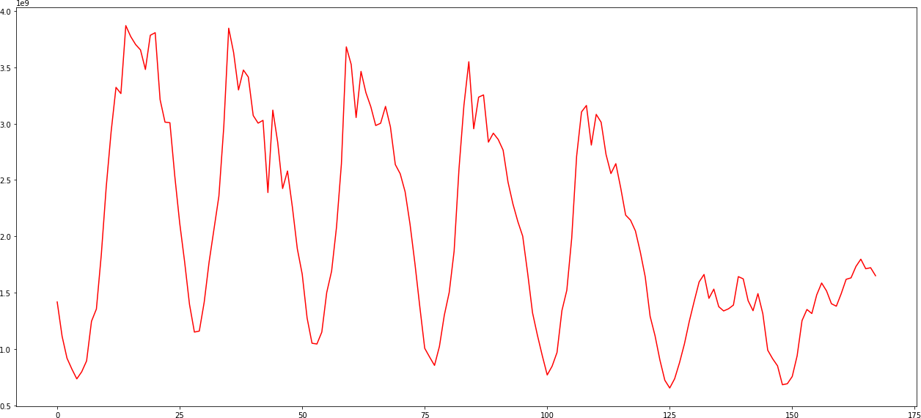

**Fig 1.2: we are plotting the first week’s data only**

Here we are plotting the first week’s data only, now the repeating pattern can be seen more clearly, and these dips in the plot in web traffic are may be occurring once every 24 hours. So clearly there are two instances of time in a day, when we have a huge traffic volume, like during a few times and when we have a modest level of traffic on the website. As in here, I will help you to

explore this data as much as possible, before getting started with model building.

## Data Preparation for Web Traffic Forecasting

Moving on now let’s prepare the data for model training, here we will create input sequences, from the block traffic data. Let’s say this is a time series. Each cell would have some number or value. Let’s create sequences of length five, so the first five observations, will form the first sequence, and the sixth observation, this one will be treated as the target.

The second sequence will start from the second element, till the sixth element and the target will be the seventh element.

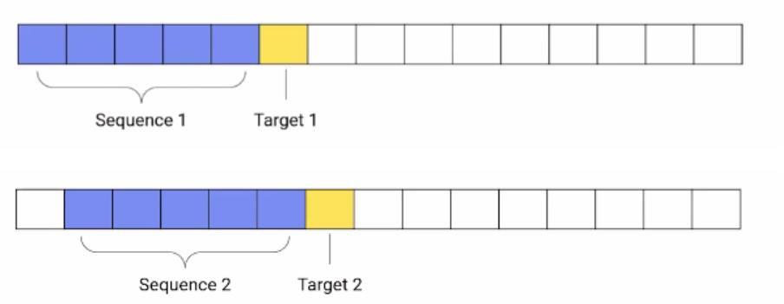

Fig 1.3: Now the subsequent sequences will be extracted, by moving this window, one step at a time.

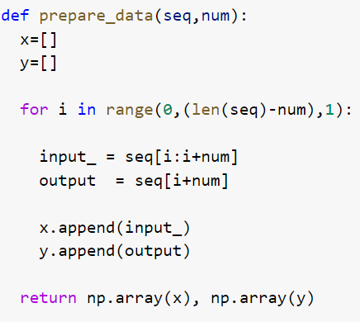

In this function, prepare data. We are using the same technique to create sequences from time-series data. We have specified the sequence length of one week or 168 hours.

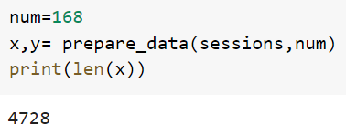

Now here we are calling this function to create sequences. The sequence length we have specified is 168 hours and that is equivalent to one week. So, we are creating sequences of one week, as our input sequences. Now the number of sequences is well over 4700.

**CHAPTER 2**

**AIM SCOPE OF THE PRESENT INVESTGATION**

* 1. **AIM:** To give the analysis of internet traffic load by deep learning concept in order to help the network service provide to optimize the network.
  2. **Scope:** One application of traffic prediction is power saving. Traffic prediction is being used in core routers of the Internet to save significant amount of power. With increasing traffic demands and computational requirements, the number and complexity of processors used in these routers are on the rise, resulting in greater power consumption.

**CHAPTER- 3**

**EXPERIMENTAL OR MATERIAL AND METHODS, ALGORITHMS USED**

## Split the Dataset

Next, we have to split the data into a training set and validation set and we will do this in the ratio, 90 is to 10. Now that sense it is a time serious problem, we are not splitting the data randomly, we are splitting it in a sequential manner.

As you can see the code below.

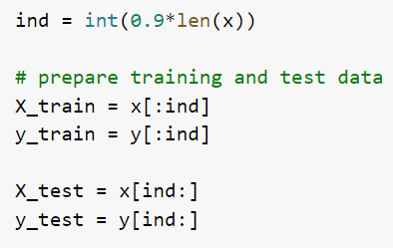

nowhere in the code we would scale the data, Both the input sequences and the target values, will be scaled because of scaling the data, speeds because of scaling the data, speeds of the model training process.

* 1. **Scaling**



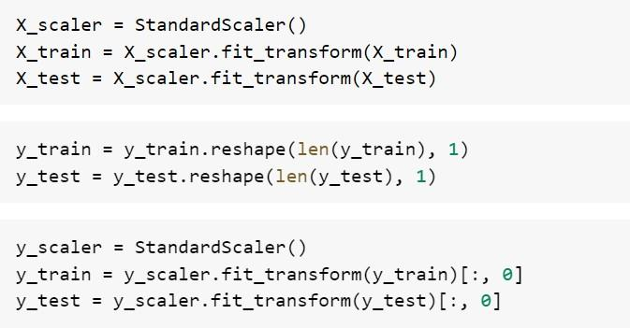

After that, we are reshaping the data from two dimensional to 3 dimensional

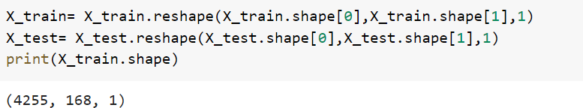

the first dimension of our data is the number of sequences, and the second dimension is the number of elements in the sequences. But LSTM layer accepts only three-dimensional data.

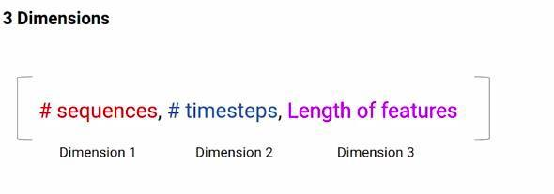

Fig no:3.1. These three dimensions are the number of sequences number of time steps and the length of the features.

So, third dimension is the length of the vectors of the sequence elements.

Let’s say I have five elements in my sequence and each of these

elements has a vector length of 10. So, this third dimension will become

10. If you can recall in the case of the auto-tagging projects the length of the sequence elements was nothing but the length of the word embeddings.

However, in this dataset, the sequence elements are real number values and therefore the feature length is just one, hence we would reshape both the training set and the validation set as shown in the above code. Now, the data is ready for model training.

In the next section, we will build our deep learning model to predict traffic using LSTM.

## : Model Building for Web Traffic Forecasting

In the previous section, we covered how time-series data is converted into sequences to train data.

And now we will use these sequences to train a deep learning model to predict future web traffic. The first thing that we do is define the model architecture.

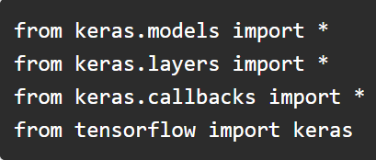

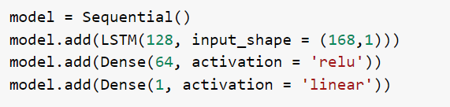

Have a look at the activation at the final layer above the code It is linear. This is because we have to predict a continuous value and not some class tag or category as it is a regression problem and not a classification problem. Other than that, we are using a single layer of LSTM here and the input shape is 168 that is one week.

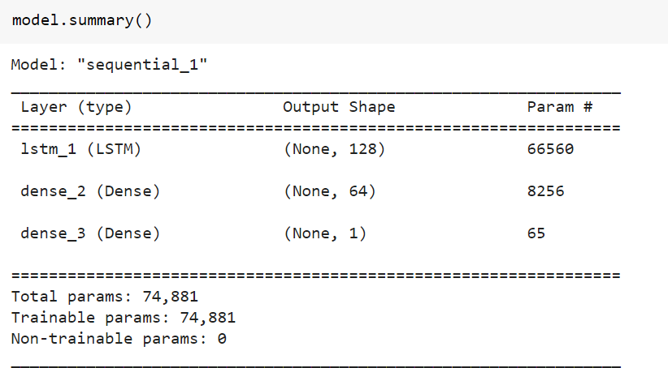

The number of train parameters is just around 74000.

## : Define the optimizer and loss

*Train the model for 30 epochs with batch size of 32*

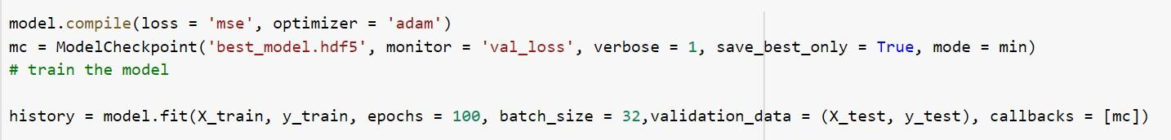

The output will be: -

WARNING: tensor flow: Model Checkpoint mode <built-in function min> is unknown, fallback to auto mode.

Epoch 1/100

133/133 [==============================] - ETA: 0s - loss: 0.1780

Epoch 1: val_loss improved from inf to 0.05674, saving model to best_model.hdf5

133/133 [==============================] - 4s 15ms/step - loss: 0.1780 - val_loss:

0.0567

Epoch 2/100

128/133 [===========================>..] - ETA: 0s - loss: 0.0399

Epoch 2: val_loss improved from 0.05674 to 0.05242, saving model to best_model. hdf5 133/133 [==============================] - 2s 12ms/step - loss: 0.0397 - val_loss:

0.0524

Epoch 3/100

131/133 [============================>.] - ETA: 0s - loss: 0.0348

Epoch 3: val_loss improved from 0.05242 to 0.04099, saving model to best_model. hdf5 133/133 [==============================] - 2s 12ms/step - loss: 0.0347 - val_loss:

0.0410

Epoch 4/100

130/133 [============================>.] - ETA: 0s - loss: 0.0321

Epoch 4: val_loss did not improve from 0.04099

133/133 [==============================] - 1s 11ms/step - loss: 0.0323 - val_loss:

0.0424

Epoch 5/100

129/133 [============================>.] - ETA: 0s - loss: 0.0322

Epoch 5: val_loss did not improve from 0.04099

133/133 [==============================] - 1s 11ms/step - loss: 0.0319 - val_loss:

0.0440

Epoch 6/100

131/133 [============================>.] - ETA: 0s - loss: 0.0308

Epoch 6: val_loss did not improve from 0.04099

133/133 [==============================] - 1s 11ms/step - loss: 0.0309 - val_loss:

0.0477

Epoch 7/100

130/133 [============================>.] - ETA: 0s - loss: 0.0299

Epoch 7: val_loss did not improve from 0.04099

133/133 [==============================] - 1s 11ms/step - loss: 0.0298 - val_loss:

0.0411

Epoch 8/100

129/133 [============================>.] - ETA: 0s - loss: 0.0286

Epoch 8: val_loss improved from 0.04099 to 0.03981, saving model to best_model.hdf5 133/133 [==============================] - 2s 11ms/step - loss: 0.0288 - val_loss:

0.0398

Epoch 9/100

129/133 [============================>.] - ETA: 0s - loss: 0.0268

Epoch 9: val_loss did not improve from 0.03981

133/133 [==============================] - 2s 11ms/step - loss: 0.0272 - val_loss:

0.0427

Epoch 10/100

132/133 [============================>.] - ETA: 0s - loss: 0.0268

Epoch 10: val_loss did not improve from 0.03981

133/133 [==============================] - 1s 11ms/step - loss: 0.0268 - val_loss:

0.0419

Epoch 11/100

132/133 [============================>.] - ETA: 0s - loss: 0.0269

Epoch 11: val_loss improved from 0.03981 to 0.03753, saving model to best_model.hdf5 133/133 [==============================] - 1s 11ms/step - loss: 0.0269 - val_loss:

0.0375

Epoch 12/100

129/133 [============================>.] - ETA: 0s - loss: 0.0248

Epoch 12: val_loss improved from 0.03753 to 0.03712, saving model to best_model.hdf5 133/133 [==============================] - 1s 11ms/step - loss: 0.0249 - val_loss:

0.0371

Epoch 13/100

128/133 [===========================>..] - ETA: 0s - loss: 0.0239

Epoch 13: val_loss did not improve from 0.03712

133/133 [==============================] - 1s 11ms/step - loss: 0.0241 - val_loss:

0.0374

Epoch 14/100

128/133 [===========================>..] - ETA: 0s - loss: 0.0230

Epoch 14: val_loss did not improve from 0.03712

133/133 [==============================] - 1s 11ms/step - loss: 0.0232 - val_loss:

0.0438

Epoch 15/100

131/133 [============================>.] - ETA: 0s - loss: 0.0238

Epoch 15: val_loss improved from 0.03712 to 0.03380, saving model to best_model.hdf5 133/133 [==============================] - 2s 11ms/step - loss: 0.0237 - val_loss:

0.0338

Epoch 16/100

132/133 [============================>.] - ETA: 0s - loss: 0.0211

Epoch 16: val_loss did not improve from 0.03380

133/133 [==============================] - 2s 11ms/step - loss: 0.0211 - val_loss:

0.0359

Epoch 17/100

131/133 [============================>.] - ETA: 0s - loss: 0.0189

Epoch 17: val_loss improved from 0.03380 to 0.02998, saving model to best_model.hdf5 133/133 [==============================] - 1s 11ms/step - loss: 0.0190 - val_loss:

0.0300

Epoch 18/100

129/133 [============================>.] - ETA: 0s - loss: 0.0189

Epoch 18: val_loss improved from 0.02998 to 0.02854, saving model to best_model.hdf5 133/133 [==============================] - 2s 12ms/step - loss: 0.0189 - val_loss:

0.0285

Epoch 19/100

129/133 [============================>.] - ETA: 0s - loss: 0.0184

Epoch 19: val_loss did not improve from 0.02854

133/133 [==============================] - 1s 11ms/step - loss: 0.0187 - val_loss:

0.0511

Epoch 20/100

130/133 [============================>.] - ETA: 0s - loss: 0.0176

Epoch 20: val_loss improved from 0.02854 to 0.02738, saving model to best_model.hdf5 133/133 [==============================] - 2s 12ms/step - loss: 0.0175 - val_loss:

0.0274

Epoch 21/100

130/133 [============================>.] - ETA: 0s - loss: 0.0174

Epoch 21: val_loss did not improve from 0.02738

133/133 [==============================] - 2s 14ms/step - loss: 0.0174 - val_loss:

0.0312

Epoch 22/100

129/133 [============================>.] - ETA: 0s - loss: 0.0174

Epoch 22: val_loss did not improve from 0.02738

133/133 [==============================] - 1s 11ms/step - loss: 0.0174 - val_loss:

0.0437

Epoch 23/100

131/133 [============================>.] - ETA: 0s - loss: 0.0174

Epoch 23: val_loss did not improve from 0.02738

133/133 [==============================] - 1s 11ms/step - loss: 0.0175 - val_loss:

0.0306

Epoch 24/100

133/133 [==============================] - ETA: 0s - loss: 0.0169

Epoch 24: val_loss did not improve from 0.02738

133/133 [==============================] - 1s 11ms/step - loss: 0.0169 - val_loss:

0.0275

Epoch 25/100

132/133 [============================>.] - ETA: 0s - loss: 0.0157

Epoch 25: val_loss did not improve from 0.02738

133/133 [==============================] - 3s 21ms/step - loss: 0.0156 - val_loss:

0.0301

Epoch 26/100

132/133 [============================>.] - ETA: 0s - loss: 0.0171

Epoch 26: val_loss did not improve from 0.02738

133/133 [==============================] - 4s 29ms/step - loss: 0.0170 - val_loss:

0.0287

Epoch 27/100

129/133 [============================>.] - ETA: 0s - loss: 0.0163

Epoch 27: val_loss did not improve from 0.02738

133/133 [==============================] - 2s 11ms/step - loss: 0.0163 - val_loss:

0.0304

Epoch 28/100

132/133 [============================>.] - ETA: 0s - loss: 0.0158

Epoch 28: val_loss did not improve from 0.02738

133/133 [==============================] - 1s 11ms/step - loss: 0.0157 - val_loss:

0.0295

Epoch 29/100

131/133 [============================>.] - ETA: 0s - loss: 0.0162

Epoch 29: val_loss did not improve from 0.02738

133/133 [==============================] - 2s 11ms/step - loss: 0.0163 - val_loss:

0.0333

Epoch 30/100

133/133 [==============================] - ETA: 0s - loss: 0.0154

Epoch 30: val_loss did not improve from 0.02738

133/133 [==============================] - 1s 11ms/step - loss: 0.0154 - val_loss:

0.0337

Epoch 31/100

130/133 [============================>.] - ETA: 0s - loss: 0.0156

Epoch 31: val_loss did not improve from 0.02738

133/133 [==============================] - 1s 11ms/step - loss: 0.0157 - val_loss:

0.0320

Epoch 32/100

133/133 [==============================] - ETA: 0s - loss: 0.0156

Epoch 32: val_loss did not improve from 0.02738

133/133 [==============================] - 1s 11ms/step - loss: 0.0156 - val_loss:

0.0301

Epoch 33/100

128/133 [===========================>..] - ETA: 0s - loss: 0.0153

Epoch 33: val_loss did not improve from 0.02738

133/133 [==============================] - 1s 11ms/step - loss: 0.0152 - val_loss:

0.0276

Epoch 34/100

130/133 [============================>.] - ETA: 0s - loss: 0.0151

Epoch 34: val_loss did not improve from 0.02738

133/133 [==============================] - 1s 11ms/step - loss: 0.0152 - val_loss:

0.0355

Epoch 35/100

133/133 [==============================] - ETA: 0s - loss: 0.0159

Epoch 35: val_loss did not improve from 0.02738

133/133 [==============================] - 2s 12ms/step - loss: 0.0159 - val_loss:

0.0314

Epoch 36/100

133/133 [==============================] - ETA: 0s - loss: 0.0150

Epoch 36: val_loss did not improve from 0.02738

133/133 [==============================] - 2s 11ms/step - loss: 0.0150 - val_loss:

0.0316

Epoch 37/100

131/133 [============================>.] - ETA: 0s - loss: 0.0157

Epoch 37: val_loss improved from 0.02738 to 0.02614, saving model to best_model.hdf5 133/133 [==============================] - 1s 11ms/step - loss: 0.0157 - val_loss:

0.0261

Epoch 38/100

133/133 [==============================] - ETA: 0s - loss: 0.0146

Epoch 38: val_loss improved from 0.02614 to 0.02595, saving model to best_model.hdf5 133/133 [==============================] - 2s 12ms/step - loss: 0.0146 - val_loss:

0.0259

Epoch 39/100

130/133 [============================>.] - ETA: 0s - loss: 0.0150

Epoch 39: val_loss did not improve from 0.02595

133/133 [==============================] - 1s 11ms/step - loss: 0.0150 - val_loss:

0.0297

Epoch 40/100

131/133 [============================>.] - ETA: 0s - loss: 0.0147

Epoch 40: val_loss did not improve from 0.02595

133/133 [==============================] - 2s 12ms/step - loss: 0.0146 - val_loss:

0.0279

Epoch 41/100

129/133 [============================>.] - ETA: 0s - loss: 0.0143

Epoch 41: val_loss did not improve from 0.02595

133/133 [==============================] - 1s 11ms/step - loss: 0.0142 - val_loss:

0.0265

Epoch 42/100

132/133 [============================>.] - ETA: 0s - loss: 0.0143

Epoch 42: val_loss did not improve from 0.02595

133/133 [==============================] - 2s 12ms/step - loss: 0.0142 - val_loss:

0.0326

Epoch 43/100

130/133 [============================>.] - ETA: 0s - loss: 0.0144

Epoch 43: val_loss did not improve from 0.02595

133/133 [==============================] - 1s 11ms/step - loss: 0.0144 - val_loss:

0.0281

Epoch 44/100

132/133 [============================>.] - ETA: 0s - loss: 0.0147

Epoch 44: val_loss did not improve from 0.02595

133/133 [==============================] - 1s 11ms/step - loss: 0.0147 - val_loss:

0.0264

Epoch 45/100

131/133 [============================>.] - ETA: 0s - loss: 0.0149

Epoch 45: val_loss did not improve from 0.02595

133/133 [==============================] - 2s 11ms/step - loss: 0.0148 - val_loss:

0.0280

Epoch 46/100

128/133 [===========================>..] - ETA: 0s - loss: 0.0141

Epoch 46: val_loss did not improve from 0.02595

133/133 [==============================] - 1s 11ms/step - loss: 0.0142 - val_loss:

0.0329

Epoch 47/100

130/133 [============================>.] - ETA: 0s - loss: 0.0142

Epoch 47: val_loss did not improve from 0.02595

133/133 [==============================] - 1s 11ms/step - loss: 0.0142 - val_loss:

0.0329

Epoch 48/100

131/133 [============================>.] - ETA: 0s - loss: 0.0139

Epoch 48: val_loss did not improve from 0.02595

133/133 [==============================] - 1s 11ms/step - loss: 0.0140 - val_loss:

0.0289

Epoch 49/100

132/133 [============================>.] - ETA: 0s - loss: 0.0141

Epoch 49: val_loss did not improve from 0.02595

133/133 [==============================] - 1s 11ms/step - loss: 0.0140 - val_loss:

0.0272

Epoch 50/100

131/133 [============================>.] - ETA: 0s - loss: 0.0140

Epoch 50: val_loss did not improve from 0.02595

133/133 [==============================] - 2s 12ms/step - loss: 0.0139 - val_loss:

0.0295

Epoch 51/100

129/133 [============================>.] - ETA: 0s - loss: 0.0143

Epoch 51: val_loss did not improve from 0.02595

133/133 [==============================] - 2s 11ms/step - loss: 0.0143 - val_loss:

0.0309

Epoch 52/100

128/133 [===========================>..] - ETA: 0s - loss: 0.0141

Epoch 52: val_loss did not improve from 0.02595

133/133 [==============================] - 1s 11ms/step - loss: 0.0141 - val_loss:

0.0270

Epoch 53/100

130/133 [============================>.] - ETA: 0s - loss: 0.0140

Epoch 53: val_loss did not improve from 0.02595

133/133 [==============================] - 1s 11ms/step - loss: 0.0140 - val_loss:

0.0314

Epoch 54/100

129/133 [============================>.] - ETA: 0s - loss: 0.0138

Epoch 54: val_loss did not improve from 0.02595

133/133 [==============================] - 1s 11ms/step - loss: 0.0139 - val_loss:

0.0351

Epoch 55/100

130/133 [============================>.] - ETA: 0s - loss: 0.0140

Epoch 55: val_loss did not improve from 0.02595

133/133 [==============================] - 1s 11ms/step - loss: 0.0140 - val_loss:

0.0316

Epoch 56/100

132/133 [============================>.] - ETA: 0s - loss: 0.0145

Epoch 56: val_loss did not improve from 0.02595

133/133 [==============================] - 2s 11ms/step - loss: 0.0146 - val_loss:

0.0290

Epoch 57/100

132/133 [============================>.] - ETA: 0s - loss: 0.0131

Epoch 57: val_loss did not improve from 0.02595

133/133 [==============================] - 2s 12ms/step - loss: 0.0130 - val_loss:

0.0286

Epoch 58/100

128/133 [===========================>..] - ETA: 0s - loss: 0.0135

Epoch 58: val_loss did not improve from 0.02595

133/133 [==============================] - 1s 11ms/step - loss: 0.0135 - val_loss:

0.0277

Epoch 59/100

132/133 [============================>.] - ETA: 0s - loss: 0.0129

Epoch 59: val_loss did not improve from 0.02595

133/133 [==============================] - 1s 11ms/step - loss: 0.0129 - val_loss:

0.0279

Epoch 60/100

131/133 [============================>.] - ETA: 0s - loss: 0.0136

Epoch 60: val_loss did not improve from 0.02595

133/133 [==============================] - 1s 11ms/step - loss: 0.0136 - val_loss:

0.0282

Epoch 61/100

133/133 [==============================] - ETA: 0s - loss: 0.0130

Epoch 61: val_loss did not improve from 0.02595

133/133 [==============================] - 2s 12ms/step - loss: 0.0130 - val_loss:

0.0302

Epoch 62/100

129/133 [============================>.] - ETA: 0s - loss: 0.0130

Epoch 62: val_loss did not improve from 0.02595

133/133 [==============================] - 1s 11ms/step - loss: 0.0129 - val_loss:

0.0263

Epoch 63/100

133/133 [==============================] - ETA: 0s - loss: 0.0129

Epoch 63: val_loss did not improve from 0.02595

133/133 [==============================] - 2s 12ms/step - loss: 0.0129 - val_loss:

0.0291

Epoch 64/100

132/133 [============================>.] - ETA: 0s - loss: 0.0138

Epoch 64: val_loss did not improve from 0.02595

133/133 [==============================] - 2s 11ms/step - loss: 0.0138 - val_loss:

0.0270

Epoch 65/100

131/133 [============================>.] - ETA: 0s - loss: 0.0133

Epoch 65: val_loss did not improve from 0.02595

133/133 [==============================] - 1s 11ms/step - loss: 0.0133 - val_loss:

0.0275

Epoch 66/100

130/133 [============================>.] - ETA: 0s - loss: 0.0129

Epoch 66: val_loss did not improve from 0.02595

133/133 [==============================] - 1s 11ms/step - loss: 0.0128 - val_loss:

0.0294

Epoch 67/100

133/133 [==============================] - ETA: 0s - loss: 0.0131

Epoch 67: val_loss did not improve from 0.02595

133/133 [==============================] - 1s 11ms/step - loss: 0.0131 - val_loss:

0.0291

Epoch 68/100

131/133 [============================>.] - ETA: 0s - loss: 0.0127

Epoch 68: val_loss did not improve from 0.02595

133/133 [==============================] - 1s 11ms/step - loss: 0.0128 - val_loss:

0.0311

Epoch 69/100

130/133 [============================>.] - ETA: 0s - loss: 0.0128

Epoch 69: val_loss did not improve from 0.02595

133/133 [==============================] - 1s 11ms/step - loss: 0.0128 - val_loss:

0.0270

Epoch 70/100

130/133 [============================>.] - ETA: 0s - loss: 0.0127

Epoch 70: val_loss did not improve from 0.02595

133/133 [==============================] - 1s 11ms/step - loss: 0.0126 - val_loss:

0.0281

Epoch 71/100

128/133 [===========================>..] - ETA: 0s - loss: 0.0129

Epoch 71: val_loss did not improve from 0.02595

133/133 [==============================] - 1s 11ms/step - loss: 0.0128 - val_loss:

0.0291

Epoch 72/100

132/133 [============================>.] - ETA: 0s - loss: 0.0129

Epoch 72: val_loss did not improve from 0.02595

133/133 [==============================] - 1s 11ms/step - loss: 0.0129 - val_loss:

0.0273

Epoch 73/100

133/133 [==============================] - ETA: 0s - loss: 0.0127

Epoch 73: val_loss did not improve from 0.02595

133/133 [==============================] - 1s 11ms/step - loss: 0.0127 - val_loss:

0.0312

Epoch 74/100

129/133 [============================>.] - ETA: 0s - loss: 0.0133

Epoch 74: val_loss did not improve from 0.02595

133/133 [==============================] - 1s 11ms/step - loss: 0.0134 - val_loss:

0.0290

Epoch 75/100

129/133 [============================>.] - ETA: 0s - loss: 0.0125

Epoch 75: val_loss did not improve from 0.02595

133/133 [==============================] - 1s 11ms/step - loss: 0.0126 - val_loss:

0.0286

Epoch 76/100

133/133 [==============================] - ETA: 0s - loss: 0.0123

Epoch 76: val_loss did not improve from 0.02595

133/133 [==============================] - 2s 11ms/step - loss: 0.0123 - val_loss:

0.0312

Epoch 77/100

131/133 [============================>.] - ETA: 0s - loss: 0.0122

Epoch 77: val_loss did not improve from 0.02595

133/133 [==============================] - 1s 11ms/step - loss: 0.0122 - val_loss:

0.0271

Epoch 78/100

130/133 [============================>.] - ETA: 0s - loss: 0.0126

Epoch 78: val_loss did not improve from 0.02595

133/133 [==============================] - 2s 11ms/step - loss: 0.0126 - val_loss:

0.0279

Epoch 79/100

128/133 [===========================>..] - ETA: 0s - loss: 0.0121

Epoch 79: val_loss did not improve from 0.02595

133/133 [==============================] - 2s 11ms/step - loss: 0.0122 - val_loss:

0.0324

Epoch 80/100

130/133 [============================>.] - ETA: 0s - loss: 0.0127

Epoch 80: val_loss did not improve from 0.02595

133/133 [==============================] - 1s 11ms/step - loss: 0.0127 - val_loss:

0.0308

Epoch 81/100

133/133 [==============================] - ETA: 0s - loss: 0.0123

Epoch 81: val_loss did not improve from 0.02595

133/133 [==============================] - 1s 11ms/step - loss: 0.0123 - val_loss:

0.0274

Epoch 82/100

128/133 [===========================>..] - ETA: 0s - loss: 0.0121

Epoch 82: val_loss did not improve from 0.02595

133/133 [==============================] - 1s 11ms/step - loss: 0.0121 - val_loss:

0.0309

Epoch 83/100

131/133 [============================>.] - ETA: 0s - loss: 0.0117

Epoch 83: val_loss did not improve from 0.02595

133/133 [==============================] - 2s 12ms/step - loss: 0.0117 - val_loss:

0.0373

Epoch 84/100

132/133 [============================>.] - ETA: 0s - loss: 0.0125

Epoch 84: val_loss did not improve from 0.02595

133/133 [==============================] - 2s 12ms/step - loss: 0.0125 - val_loss:

0.0316

Epoch 85/100

129/133 [============================>.] - ETA: 0s - loss: 0.0120

Epoch 85: val_loss did not improve from 0.02595

133/133 [==============================] - 2s 12ms/step - loss: 0.0120 - val_loss:

0.0291

Epoch 86/100

130/133 [============================>.] - ETA: 0s - loss: 0.0120

Epoch 86: val_loss did not improve from 0.02595

133/133 [==============================] - 2s 12ms/step - loss: 0.0120 - val_loss:

0.0306

Epoch 87/100

133/133 [==============================] - ETA: 0s - loss: 0.0117

Epoch 87: val_loss did not improve from 0.02595

133/133 [==============================] - 2s 11ms/step - loss: 0.0117 - val_loss:

0.0300

Epoch 88/100

132/133 [============================>.] - ETA: 0s - loss: 0.0117

Epoch 88: val_loss did not improve from 0.02595

133/133 [==============================] - 1s 11ms/step - loss: 0.0117 - val_loss:

0.0290

Epoch 89/100

130/133 [============================>.] - ETA: 0s - loss: 0.0117

Epoch 89: val_loss did not improve from 0.02595

133/133 [==============================] - 2s 11ms/step - loss: 0.0117 - val_loss:

0.0283

Epoch 90/100

132/133 [============================>.] - ETA: 0s - loss: 0.0118

Epoch 90: val_loss did not improve from 0.02595

133/133 [==============================] - 2s 11ms/step - loss: 0.0118 - val_loss:

0.0293

Epoch 91/100

133/133 [==============================] - ETA: 0s - loss: 0.0115

Epoch 91: val_loss did not improve from 0.02595

133/133 [==============================] - 2s 12ms/step - loss: 0.0115 - val_loss:

0.0346

Epoch 92/100

131/133 [============================>.] - ETA: 0s - loss: 0.0117

Epoch 92: val_loss did not improve from 0.02595

133/133 [==============================] - 2s 12ms/step - loss: 0.0116 - val_loss:

0.0272

Epoch 93/100

129/133 [============================>.] - ETA: 0s - loss: 0.0113

Epoch 93: val_loss did not improve from 0.02595

133/133 [==============================] - 2s 12ms/step - loss: 0.0114 - val_loss:

0.0303

Epoch 94/100

133/133 [==============================] - ETA: 0s - loss: 0.0116

Epoch 94: val_loss did not improve from 0.02595

133/133 [==============================] - 2s 12ms/step - loss: 0.0116 - val_loss:

0.0266

Epoch 95/100

131/133 [============================>.] - ETA: 0s - loss: 0.0114

Epoch 95: val_loss did not improve from 0.02595

133/133 [==============================] - 2s 12ms/step - loss: 0.0115 - val_loss:

0.0298

Epoch 96/100

129/133 [============================>.] - ETA: 0s - loss: 0.0116

Epoch 96: val_loss did not improve from 0.02595

133/133 [==============================] - 2s 12ms/step - loss: 0.0116 - val_loss:

0.0303

Epoch 97/100

130/133 [============================>.] - ETA: 0s - loss: 0.0111

Epoch 97: val_loss did not improve from 0.02595

133/133 [==============================] - 2s 13ms/step - loss: 0.0112 - val_loss:

0.0274

Epoch 98/100

131/133 [============================>.] - ETA: 0s - loss: 0.0113

Epoch 98: val_loss did not improve from 0.02595

133/133 [==============================] - 2s 14ms/step - loss: 0.0113 - val_loss:

0.0281

Epoch 99/100

130/133 [============================>.] - ETA: 0s - loss: 0.0110

Epoch 99: val_loss did not improve from 0.02595

133/133 [==============================] - 2s 12ms/step - loss: 0.0111 - val_loss:

0.0307

Epoch 100/100

129/133 [============================>.] - ETA: 0s - loss: 0.0112

Epoch 100: val_loss did not improve from 0.02595

133/133 [==============================] - 2s 12ms/step - loss: 0.0111 - val_loss:

0.0301

## 3.5. Define the call back to save the best model during the training

Load the weights of best model prior to predictions. Now here we will use the mean squared error and we are using model checkpoint again to save the best model weight.



finally, the model training starts and moving on the evaluation starts here and moving on to the evaluation part, the mean squared error for the validation data is just 0.013. Evaluate the performance of the model on the validation data.

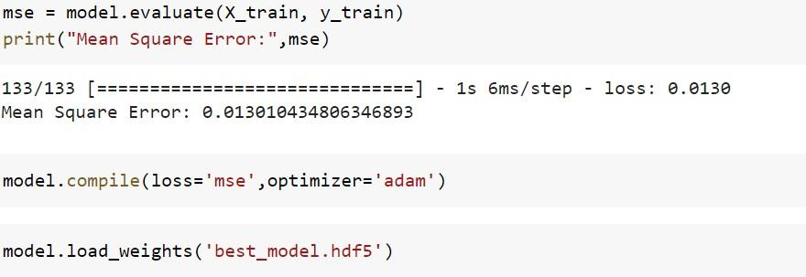

Now, whenever we are working on a project it is always a good practice to have a baseline model, just to have an idea of how good your model is with respect to the baseline predictions.

## : Baseline Model with Forecasting

So here we are using a simple moving average as the baseline model. So what we will do, we will take a sequence and its length is the same 168 elements. And then we take average this sequence and we compare this average with the target value.







So, this function computes the average of the input sequences and over here we are extracting the predictions.



Now we calculate the mean squared error for this model. On the same validation data, we get a score of 0.554 which is way higher than this previous error.



So, our LSTM based model has done exceptionally well as compared to the baseline model,

## Now moving on to forecasting. These are the steps that we will follow: -

1. first, initialize an array with weeks data,
2. Predict the next hour traffic volume
3. Append the predicted value at the end of the array ‘data
4. Skip the first element of the array ‘data’
5. Repeating steps, from the second step till the fourth step for the specified number of iterations.

This is how we can forecast for any number of hours in future. This function forecast performs the steps just discuss and it returns the predicted sequence of numbers.

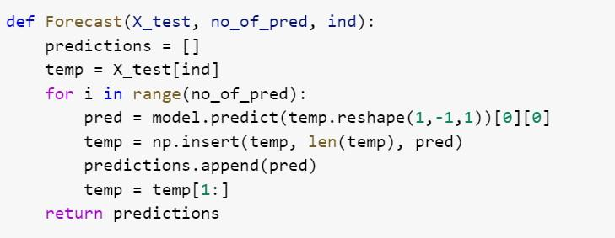

It’s time to forecast the traffic for the next 24 hours based on the previous week data.

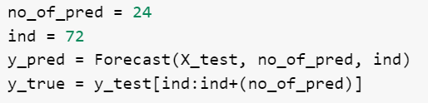

| 1/1 | [==============================] | - 1s | 637ms/step |
| --- | --- | --- | --- |
| 1/1 | [==============================] | - 0s | 19ms/step |
| 1/1 | [==============================] | - 0s | 20ms/step |
| 1/1 | [==============================] | - 0s | 20ms/step |
| 1/1 | [==============================] | - 0s | 20ms/step |
| 1/1 | [==============================] | - 0s | 21ms/step |
| 1/1 | [==============================] | - 0s | 20ms/step |
| 1/1 | [==============================] | - 0s | 20ms/step |
| 1/1 | [==============================] | - 0s | 19ms/step |
| 1/1 | [==============================] | - 0s | 19ms/step |
| 1/1 | [==============================] | - 0s | 20ms/step |

| 1/1 | [==============================] | - 0s | 20ms/step |
| --- | --- | --- | --- |
| 1/1 | [==============================] | - 0s | 22ms/step |
| 1/1 | [==============================] | - 0s | 20ms/step |
| 1/1 | [==============================] | - 0s | 19ms/step |
| 1/1 | [==============================] | - 0s | 19ms/step |
| 1/1 | [==============================] | - 0s | 20ms/step |
| 1/1 | [==============================] | - 0s | 20ms/step |
| 1/1 | [==============================] | - 0s | 22ms/step |
| 1/1 | [==============================] | - 0s | 20ms/step |
| 1/1 | [==============================] | - 0s | 21ms/step |
| 1/1 | [==============================] | - 0s | 20ms/step |
| 1/1 | [==============================] | - 0s | 22ms/step |
| 1/1 | [==============================] | - 0s | 22ms/step |

*Define a function which forecasts the traffic for the next hours from the previous*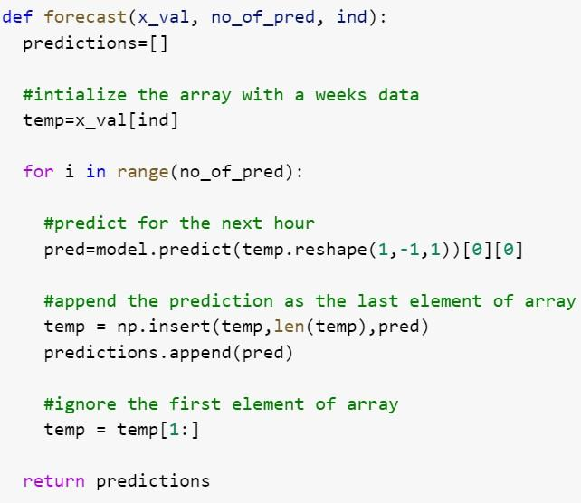

*week data.*

Double-click (or enter) to edit

*Now let’s look at the plot of real vs forecast values*

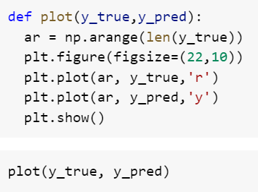

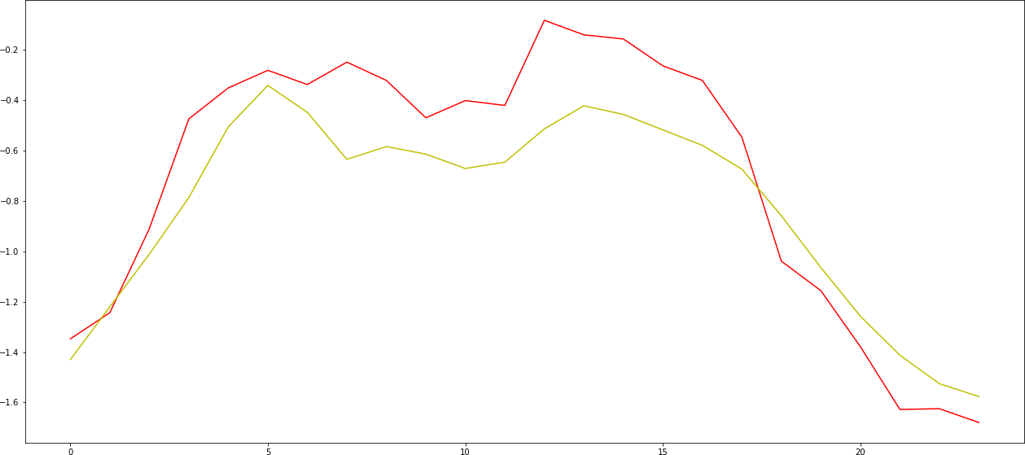

3.2: The Red curve is the actual value and the yellow curve is our predicted value and both are pretty much close to each other**.**

Similarly, we can use a CNN based model in place of LSTM to perform the

same task. Let’s see how it is done.

## CNN Model with Forecasting

Now here we are using Conv1D layers in the model architecture. And these layers are followed by a flattening layer. This layer converts the input to a One-Dimensional array, which is then passed on to this set of dense layers.



The output will be: -

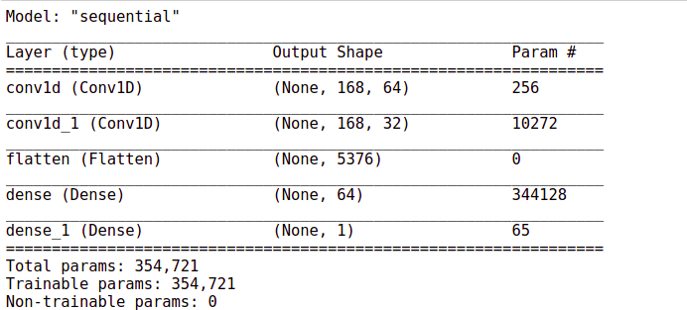



Here again, you can see that the training process is processing fast. It is hardly taking one second to finish and pip off.





133/133 [==============================] - 4s 23ms/step - loss:

0.0899 - val_loss: 0.0482

Epoch 00001: val_loss improved from inf to 0.04819, saving model to best_model.hdf5

Epoch 2/30

133/133 [==============================] - 3s 22ms/step - loss:

0.0249 - val_loss: 0.0209

Epoch 00002: val_loss improved from 0.04819 to 0.02086, saving model to best_model.hdf5

Epoch 3/30

133/133 [==============================] - 3s 22ms/step - loss:

0.0186 - val_loss: 0.0190

Epoch 00003: val_loss improved from 0.02086 to 0.01899, saving model to best_model.hdf5

Epoch 4/30

133/133 [==============================] - 3s 23ms/step - loss:

0.0157 - val_loss: 0.0161

Epoch 00004: val_loss improved from 0.01899 to 0.01610, saving model to best_model.hdf5

Epoch 5/30



133/133 [==============================] - 3s 20ms/step - loss:

0.0132 - val_loss: 0.0149

Epoch 00005: val_loss improved from 0.01610 to 0.01490, saving model to best_model.hdf5

Epoch 6/30

133/133 [==============================] - 3s 21ms/step - loss:

0.0134 - val_loss: 0.0158

Epoch 00006: val_loss did not improve from 0.01490

Epoch 7/30

133/133 [==============================] - 3s 22ms/step - loss:

0.0122 - val_loss: 0.0138

Epoch 00007: val_loss improved from 0.01490 to 0.01385, saving model to best_model.hdf5

Epoch 8/30

133/133 [==============================] - 3s 23ms/step - loss:

0.0112 - val_loss: 0.0146

Epoch 00008: val_loss did not improve from 0.01385

Epoch 9/30

133/133 [==============================] - 3s 21ms/step - loss:

0.0106 - val_loss: 0.0177



Epoch 00009: val_loss did not improve from 0.01385

Epoch 10/30

133/133 [==============================] - 3s 21ms/step - loss:

0.0092 - val_loss: 0.0131

Epoch 00010: val_loss improved from 0.01385 to 0.01314, saving model to best_model.hdf5

Epoch 11/30

133/133 [==============================] - 3s 23ms/step - loss:

0.0089 - val_loss: 0.0167

Epoch 00011: val_loss did not improve from 0.01314

Epoch 12/30

133/133 [==============================] - 3s 22ms/step - loss:

0.0083 - val_loss: 0.0148

Epoch 00012: val_loss did not improve from 0.01314

Epoch 13/30

133/133 [==============================] - 3s 21ms/step - loss:

0.0078 - val_loss: 0.0154

Epoch 00013: val_loss did not improve from 0.01314

Epoch 14/30



133/133 [==============================] - 3s 21ms/step - loss:

0.0073 - val_loss: 0.0142

Epoch 00014: val_loss did not improve from 0.01314

Epoch 15/30

133/133 [==============================] - 3s 21ms/step - loss:

0.0064 - val_loss: 0.0144

Epoch 00015: val_loss did not improve from 0.01314

Epoch 16/30

133/133 [==============================] - 3s 22ms/step - loss:

0.0057 - val_loss: 0.0153

Epoch 00016: val_loss did not improve from 0.01314

Epoch 17/30

133/133 [==============================] - 3s 22ms/step - loss:

0.0050 - val_loss: 0.0158

Epoch 00017: val_loss did not improve from 0.01314

Epoch 18/30

133/133 [==============================] - 3s 22ms/step - loss:

0.0051 - val_loss: 0.0155

Epoch 00018: val_loss did not improve from 0.01314



Epoch 19/30

133/133 [==============================] - 3s 20ms/step - loss:

0.0044 - val_loss: 0.0153

Epoch 00019: val_loss did not improve from 0.01314

Epoch 20/30

133/133 [==============================] - 3s 21ms/step - loss:

0.0040 - val_loss: 0.0144

Epoch 00020: val_loss did not improve from 0.01314

Epoch 21/30

133/133 [==============================] - 3s 22ms/step - loss:

0.0033 - val_loss: 0.0147

Epoch 00021: val_loss did not improve from 0.01314

Epoch 22/30

133/133 [==============================] - 3s 20ms/step - loss:

0.0031 - val_loss: 0.0153

Epoch 00022: val_loss did not improve from 0.01314

Epoch 23/30

133/133 [==============================] - 3s 22ms/step - loss:

0.0030 - val_loss: 0.0161



Epoch 00023: val_loss did not improve from 0.01314

Epoch 24/30

133/133 [==============================] - 3s 22ms/step - loss:

0.0026 - val_loss: 0.0150

Epoch 00024: val_loss did not improve from 0.01314

Epoch 25/30

133/133 [==============================] - 3s 23ms/step - loss:

0.0025 - val_loss: 0.0161

Epoch 00025: val_loss did not improve from 0.01314

Epoch 26/30

133/133 [==============================] - 3s 21ms/step - loss:

0.0026 - val_loss: 0.0151

Epoch 00026: val_loss did not improve from 0.01314

Epoch 27/30

133/133 [==============================] - 3s 20ms/step - loss:

0.0026 - val_loss: 0.0151

Epoch 00027: val_loss did not improve from 0.01314

Epoch 28/30

133/133 [==============================] - 3s 21ms/step - loss:

0.0023 - val_loss: 0.0160



Load the weights of the best model prior to predictions.



Let’s check out the performance of this model on the validation set.

Evaluate the performance of a model on the validation data.

mse | Web Traffic Forecasting

The mean squared error has improved the width from 0.015 to 0.013.

## 3.7.1. Comparison with the baseline model

Now let’s compare this performance with the baseline model.

MSE

The baseline score was 0.55. So our CNN based model is also much better than the baseline model.

Forecasting

Now let’s see how well it forecast the web traffic for a period of 24 hours.





It’s time to forecast the traffic for the next 24 hours based on the

previous week data.



Let’s convert back the normalized values to the original dimensional space.





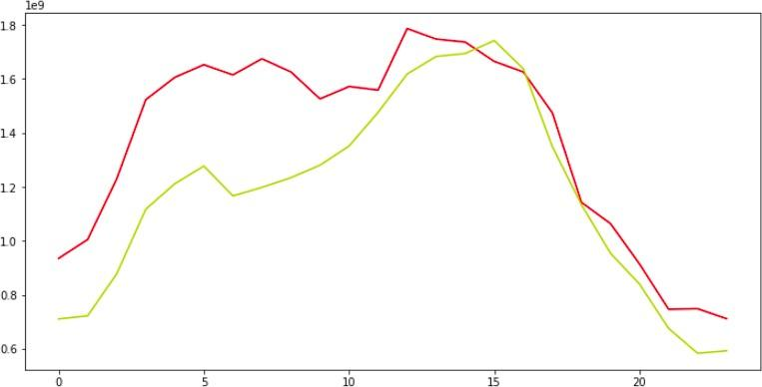

3.3: The forecasted values are almost close to the actual values. Well, the performance seems pretty much similar to that of the LSTM in the based model.

If You can recall in the Auto-tagging system project we saw that the CNN- based model outperform the LSTM based model by a huge margin.

But here in this case both the models have performed mode or less the same.

# Conclusion

However, the CNN-based model still has the advantage of speed. Now, this is not the end of the row. We can further improve this model by taking measures like, we can make the time series data stationary and then use it for making sequences and then later use it in the model input sequences. To learn more about stationarity charity and other time series- related concepts, you can check out this [link](https://www.analyticsvidhya.com/blog/2016/02/time-series-forecasting-codes-python/)**.**

Apart from that, we can also try a different number of hidden units r different numbers of hidden layers. To see how our model performs under different settings. In addition, we can also try to change the learning rate. Even that might help in improving the model.

# References

1. Feng, H., Shu, Y.: Study on network trafﬁc prediction techniques. In: International Conference on Wireless Communications, Networking and Mobile Computing, vol. 2, pp. 1041–1044. IEEE (2005)
2. Floyd, S., Paxson, V.: Difﬁculties in simulating the internet. IEEE/ACM Trans. Netw. (TON) **9**(4), 392–403 (2001)
3. Shang, P., Li, X., Kamae, S.: Nonlinear analysis of trafﬁc time series at different temporal scales. Phys. Lett. A **357**(4), 314–318 (2006)
4. Shang, P., Li, X., Kamae, S.: Chaotic analysis of traffic time series. Chaos, Solitons Fractals 25(1), 121–128 (2005)
5. Romeu, P., Zamora-Martínez, F., Botella-Rocamora, P., Pardo, J.: Time-series forecasting of indoor temperature using pre-trained deep neural networks. In: International Conference on Artificial Neural Networks, pp. 451–458. Springer, Heidelberg (2013)
6. You, C., Chandra, K.: Time series models for internet data traffic. In: 1999 Conference on Local Computer Networks, LCN’99, pp. 164–171. IEEE (1999)
7. Dalto, M.: Deep neural networks for time series prediction with applications in ultra-short- term wind forecasting. In: IEEE ICIT (2015)
8. Bengio, Y.: Learning deep architectures for AI. Foundations and trends®. Mach. Learn. 2(1), 1–127 (2009)